
Tribhuvan University
Faculty of Humanities and Social Science

Project Report on
“Adaptive Data Visualization System (ADVS)”

Submitted to
Department of Computer Application
Padmashree International College
Tinkune, Kathmandu

In partial fulfillment of the requirements for Bachelors in Computer Application
Submitted by
Khesehang Yonghang
BCA 8thSemester
University Registration Number:
6-2-622-38-2020

Under Supervision of
Mr. Basanta Chapagain

Tribhuvan University
Faculty of Humanities and Social Science
Padmashree International College

SUPERVISOR’S RECOMMENDATION
I hereby recommend that this project report is prepared under my supervision by Khesehang Yonghang entitled “Adaptive Data Visualization System” in partial fulfillment of requirements for the degree of Bachelor of Computer Application recommended for the final evaluation.

……………………………
Basanta Chapagain
Project Supervisor
Department of Computer Application
Padmashree International College

Tribhuvan University
Faculty of Humanities and Social Science
Padmashree International College

LETTER OF APPROVAL
This is to certify that this report prepared by Khesehang Yonghang entitled “Adaptive Data Visualization System” in partial fulfillment of the requirements for the degree of Bachelor’s in Computer Application has been evaluated. In my opinion, it is satisfactory in the scope and quality as a project for the required degree.
……………………………  Mr. Basanta Chapagain  Project Supervisor  Department of Computer Application  Padmashree International College | ……………………………….  Mr. Ramesh Kumar Pudasaini  BCA Coordinator  Department of Computer Application  Padmashree International College
……………………………  Internal Examiner  Basanta Chapagain | ………………………………  External Examiner

ACKNOWLEDGEMENT
I would like to take this opportunity to express my sincere thanks to the Bachelors of Computer Application, Tribhuvan University for providing me this opportunity to explore our interest and idea in the field of computer software through the “Project - III” In addition, I would also like to thank, FOHSS, which include this topic on the curriculum of the 8th semester.
It gives me immense pleasure to explore my deepest sense of gratitude and sincere thanks to our supervisor Basanta Chapagain who gave us this golden opportunity to this wonderful project on the topic “Adaptive Data Visualization System”, which also helped me in doing a lot of research and I came to know about many new tools and technologies.
Moreover, I would like to thank our coordinator Mr. Ramesh Kumar Pudasaini for arranging a good favorable environment to complete our project. Finally, my parents and friends who helped me a lot in finalizing this project in the limited time are also highly thanked.

ABSTRACT
The Adaptive Data Visualization System (ADVS) is an intelligent platform designed to democratize data analysis by automating the selection and generation of appropriate visualizations based on dataset characteristics. Traditional visualization tools often require significant statistical expertise and manual chart selection, creating barriers for non-technical users. ADVS addresses this challenge through a machine learning-driven approach that employs data profiling algorithms to analyze variable types, distributions, and relationships within uploaded datasets.
The system utilizes a RandomForestClassifier combined with ClassifierChain to intelligently recommend optimal visualization types, including bar charts, scatter plots, histograms, and correlation heatmaps, tailored to the specific data structure and analytical context. To enhance interpretability and user understanding, ADVS integrates an AI-powered summarization module leveraging Llama 3, a large language model, which generates concise natural language explanations of visualized patterns, trends, and insights. Supporting common data formats, including CSV the system provides a user-friendly interface that enables both technical and non-technical users to upload datasets, view automatically generated visualizations, and comprehend data implications without requiring deep analytical expertise. By combining adaptive machine learning-based visualization selection with automated AI-generated summaries, ADVS facilitates faster, more accurate data-driven decision-making across academic, business, and research domains, ultimately bridging the gap between raw data and actionable insights.
Keywords: Adaptive Data Visualization, Machine Learning, RandomForestClassifier, ClassifierChain, Automated Chart Selection, Data Profiling, Exploratory Data Analysis.

TABLE OF CONTENTS
CHAPTER 1. INTORDUCTION 1
1.1 Introduction 1
1.2 Problem Statement 1
1.3 Objectives 2
1.4 Scope and Limitations 2
1.4.1 Scope 2
1.4.2 Limitations 2
1.5 Development Methodology 3
1.6 Report Organization 4
CHAPTER 2. BACKGROUND STUDY AND LITERATURE REVIEW 5
2.1 Background Study 5
2.2 Literature Review 7
CHAPTER 3. SYSTEM ANALYSIS AND DESIGN 9
3.1 System Analysis 9
3.1.1 Requirement Analysis 9
3.1.2 Feasibility Study 12
3.1.3 Object Modelling: Class & Object Diagram 13
3.1.4 Dynamic Modelling: State and Sequence Diagram 15
3.1.5 Process Modelling: Activity Diagram 19
3.2 System Design 22
3.2.1 Refinement of Classes and Objects 22
3.2.2 Component Diagram 25
3.2.3 Deployment Diagram 26
3.3 Algorithm 27
CHAPTER 4. IMPLEMENTATION AND TESTING 31
4.1 Implementation 31
4.1.1 Tools Used 31
4.1.2 Implementation Details of Modules 32
4.2 Testing 42
4.2.1 Test Cases for Unit Testing 42
4.2.2 Test Cases for System Testing 46
4.3 Result Analysis 47
4.3.1 Evaluating Accuracy 47
4.3.2 Evaluating Accuracy of the Model 50
CHAPTER 5. CONCLUSION AND FUTURE RECOMMENDATION 53
5.1 Conclusion 53
5.2 Future Recommendations 53
REFERENCES
APPENDICES 1

List of Abbreviations
ADVS | Adaptive Data Visualization System
AI | Artificial Intelligence
API | Application Programming Interface
CRUD | Create Read Update Delete
CSV | Comma Separated Values
DFD | Data Flow Diagram
EDA | Exploratory Data Analysis
ERD | Entity Relationship Diagram
IEEE | Institute of Electrical and Electronics Engineers
IRD | In-land Revenue Department
IT | Information Technology
JSON | JavaScript Object Notation
LSTM | Long Short-Term Memory
PAN | Permanent Account Number
PDF | Portable Document Format
PNG | Portable Network Graphics
REST | REpresentational State Transfer
RNN | Recurrent Neural Networks
SVG | Scalable Vector Graphics
UI | User Interface
UX | User Experience
XML | eXtensible Markup Language

List of TABLES
Table 3.1: Description of the Use Cases 11
Table 4.1: Unit Tests for Authentication Module 42
Table 4.2: Unit Tests for Dataset Upload Module 43
Table 4.3: Unit Tests for Data Profiling Module 43
Table 4.4: Unit Tests for ML Classifier Module 44
Table 4.5: Unit Tests for Summary Generation Module 45
Table 4.6: End-to-End Workflow Test 46
Table 4.7: Integration Test 46
Table 4.8:Per Class Metric to Evaluate Performance 50
Table 4.9: ROC-AUC Curve for Classification 51
Table 4.10: Model Comparison 52

LIST OF FIGURES
Figure 1.1: Waterfall Model of ADVS 3
Figure 3.1: Use Case Diagram of Adaptive Data Visualization System (ADVS) 10
Figure 3.2: Gantt Chart of ADVS 13
Figure 3.3: Class Diagram of ADVS 14
Figure 3.4: Object Diagram 15
Figure 3.5: State Diagram of ADVS 17
Figure 3.6: Sequence Diagram of ADVS 19
Figure 3.7: ADVS Activity Diagram 21
Figure 3.8: Refinement of Class Diagram 23
Figure 3.9: Refinement of Object Diagram 25
Figure 3.10: Component Diagram for ADVS 26
Figure 3.11: Deployment Diagram of ADVS 26
Figure 3.12: Forward Chaining Algorithm Example 27

INTORDUCTION

Introduction
In the age of data-driven decision-making, it is very important to be able to read and share insights from data well. Many traditional data visualization tools require users to know how to use statistics and choose the right chart, which can be hard for people who aren't experts. To solve this problem, this project suggests an Adaptive Data Visualization System (ADVS). This smart platform automatically chooses the best way to show data based on what kind of data it is and how it is structured.
The system uses data profiling algorithms to look at the characteristics of datasets, like the types of variables, their distributions, and their relationships. It then dynamically suggests or creates the most useful visualization, like bar charts for categorical data, scatter plots for bivariate analysis, or heatmaps for correlations.
Furthermore, to enhance interpretability, ADVS integrates an AI-powered summarization module, inspired by natural language models like ChatGPT, which generates concise textual explanations of the visualized data. This empowers users not only to see the data more clearly but also to understand its implications without needing deep analytical expertise.
By combining adaptive visualization with automated summarization, ADVS aims to democratize data analysis and facilitate faster, more accurate insights across academic, business, and research domains.

Problem Statement
Despite the increasing availability of data visualization tools, many users struggle to select appropriate chart types for different data structures and analytical goals. This often leads to misinterpretation, poor decision-making, or reliance on expert guidance. Furthermore, static visualizations lack explanatory context, making it difficult for non-technical users to draw accurate conclusions. There is a need for a system that not only automates visualization selection based on data properties but also provides clear, human-readable summaries of the resulting insights.

Objectives
Some of the objectives of the system are as follows:
- To develop a system that intelligently analyzes the structure and type of input data and automatically selects suitable visualization techniques.
- To integrate an AI-based summarization module that generates natural language explanations of the visualized data to enhance user understanding.
- To provide an interface that allows both technical and non-technical users to upload datasets, view visualizations, and read concise summaries without needing deep analytical skills.

Scope and Limitations

Scope
The scopes of ADVS are as follows:
- The system will support commonly used data formats (e.g., CSV, Excel) and handle basic data types such as numerical, categorical, temporal, and boolean.
- Visualization techniques will include basic and intermediate chart types such as bar charts, pie charts, line graphs, scatter plots, histograms, and correlation heatmaps.
- The summarization component will provide textual explanations based on trends, distributions, and relationships present in the data, using pre-trained natural language models.

Limitations
- Data Format Constraints: The system is limited to commonly used structured data formats (CSV, Excel, JSON) and does not support unstructured data sources such as images, videos, audio files, or real-time streaming data from APIs or databases.
- Data Type Coverage: The system handles only basic data types (numerical, categorical, temporal, and boolean) and may not effectively process complex data structures such as geospatial coordinates, hierarchical/nested data, graph networks, or multi-dimensional arrays.
- Visualization Complexity: The system provides basic to intermediate chart types and does not support advanced or specialized visualizations such as 3D plots, interactive dashboards with drill-down capabilities, animated time-series visualizations, network graphs, or domain-specific charts (e.g., Sankey diagrams, treemaps, Gantt charts).
- Scalability and Performance: The system's performance may degrade with extremely large datasets (millions of rows or thousands of columns), as data profiling and machine learning model inference require computational resources that may exceed typical system capabilities.
- Model Accuracy: The RandomForestClassifier's visualization recommendations depend on the training data quality and coverage. The system may produce suboptimal suggestions for datasets with unusual distributions, rare data patterns, or domain-specific contexts not represented in the training corpus.
- Summarization Depth: While the Llama 3-based summarization module generates natural language explanations, it is limited to general pattern recognition and may lack domain-specific expertise or deep contextual understanding required for specialized fields (e.g., medical diagnostics, financial forecasting, scientific research).
- Language Support: The AI-generated summaries are primarily optimized for English language output and may not support multilingual explanations or culturally-specific interpretations of data insights.

Development Methodology
The system is built under the Waterfall methodology. It was selected for the system because of the fact that the requirements were well-defined and weren’t changing over time.
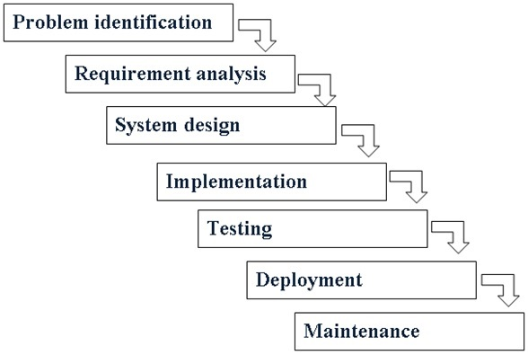
Figure 1.1: Waterfall Model of ADVS

Report Organization
Chapter 1: Introduction
This chapter deals with the introduction of the system regarding its objectives, scope and limitations alongside the reason the system is made. In addition, this chapter also covers the development methodology of the project.
Chapter 2: Background Study and Literature Review
Here in this chapter, the information regarding the background information of event detection and analysis with their system is covered. Likewise, the chapter also includes a review of existing system similar to the project with their advantages and disadvantages.
Chapter 3: System Analysis and Design
Under this chapter, overall system analysis and design component are described. Different software requirements, i.e., functional and non-functional requirements along with various feasibility study are also elaborated in this system analysis part. In addition, class: object diagram, sequence diagram, activity diagram and flowchart are also included in this chapter.
Chapter 4: Implementation and Testing
In this chapter different tools for implementing the system like programming languages, database platforms, case tools are included. Similarly, testing of different modules are also included here. Result analysis of the model with its improvement scores, along with visualizations is also included in this chapter.
Chapter 5: Conclusion and Future Recommendation
The chapter contains the lesson learned throughout the system development process, system outcome and conclusion are noted here. The future recommendation and enhancement part for enhancing the system from the developer perspective are also listed under this chapter.

BACKGROUND STUDY AND LITERATURE REVIEW

Background Study
Data visualization has been a cornerstone of information communication for centuries, dating back to early statistical graphics in the 18th century. However, the digital revolution and exponential growth of data in the 21st century have transformed visualization from a specialized skill into a critical necessity across virtually all domains. Organizations today generate massive volumes of data, and the ability to extract meaningful insights from this data has become a competitive advantage. Traditional approaches to data visualization required users to possess substantial knowledge of statistical principles, chart selection criteria, and the technical proficiency to operate complex software tools, barriers that limited data analysis to specialized analysts and data scientists.
One of the most fundamental challenges in data visualization is selecting the appropriate chart type for a given dataset and analytical goal. Research has shown that inappropriate visualization choices can lead to misinterpretation of data, flawed decision-making, and loss of valuable insights. According to Cleveland and McGill's seminal work on graphical perception, different visualization techniques encode information with varying levels of perceptual accuracy, making some charts inherently more suitable for certain data types and analytical tasks than others [1]. For instance, bar charts excel at comparing categorical values, line graphs effectively display temporal trends, and scatter plots reveal correlations between continuous variables. However, non-expert users often lack the knowledge to make these informed choices, resulting in visualizations that obscure rather than illuminate insights.
Recognizing these challenges, researchers and industry practitioners have developed various automated visualization systems aimed at reducing the cognitive burden on users. Systems like Voyager, developed at the University of Washington, pioneered the concept of exploratory analysis through faceted browsing of visualization recommendations. Voyager employs statistical and perceptual measures to generate and rank multiple visualization alternatives, allowing users to interactively navigate through recommended charts. This mixed-initiative approach demonstrated that automated guidance could significantly enhance data exploration efficiency and variable coverage.
Building on these foundations, Data2Vis introduced a neural translation approach, framing visualization generation as a sequence-to-sequence problem. Using attention-based recurrent neural networks with LSTM units, Data2Vis learned to map dataset specifications to visualization specifications in declarative languages like Vega-Lite. This deep learning approach showed promise in generating visualizations comparable to those created manually by experts, but in a fraction of the time.
Commercial platforms have also embraced automation. Tableau, acquired by Salesforce, incorporates the "Show Me" feature that automatically suggests mark types and view configurations based on selected data fields. This intelligent assistance has made Tableau one of the most popular business intelligence tools globally. Similarly, Google's Looker Studio leverages Google's AI technologies to provide automated chart suggestions and natural language summaries for business intelligence applications, making data analysis more accessible to non-technical stakeholders.
In the open-source ecosystem, AutoViz has gained traction by offering single-line-of-code visualization generation for exploratory data analysis, emphasizing speed and simplicity over customization depth.
Recent advances in machine learning have opened new possibilities for intelligent visualization systems. Classification algorithms, particularly ensemble methods like Random Forests, have proven effective at learning complex decision boundaries for multi-class problems. In the context of visualization selection, machine learning models can be trained on curated datasets of data characteristics and appropriate chart types, learning the implicit rules that guide expert visualization designers. The RandomForestClassifier, with its ability to handle non-linear relationships and provide feature importance rankings, is particularly well-suited for this task. When combined with ClassifierChain for handling multiple visualization recommendations simultaneously, these algorithms can adapt to diverse dataset structures and user needs.
While automated chart generation addresses the technical barrier of visualization creation, a complementary challenge remains: helping users interpret and understand the insights revealed by visualizations. This is where natural language generation (NLG) technologies become invaluable. The recent emergence of large language models (LLMs) such as GPT, Claude, and Llama has revolutionized automated text generation across numerous domains. These models, trained on vast corpora of text, can generate coherent, contextually appropriate explanations that bridge the gap between visual patterns and human understanding.
Llama 3, developed by Meta AI, represents a significant advancement in open-source large language models, offering strong performance in natural language understanding and generation tasks. [2] By integrating such models into visualization systems, it becomes possible to automatically generate summaries that describe trends, highlight outliers, explain correlations, and provide actionable insights, all in natural, accessible language that non-technical users can readily comprehend.

Literature Review
Voyager: Exploratory Analysis via Faceted Browsing of Visualization Recommendations, a paper published on the IEEE is a mixed-initiative system that supports faceted browsing of recommended charts chosen according to statistical and perceptual measures. The system was designed with the aim to facilitate manual chart construction with interactive navigation of a gallery of automatically-generated visualizations. Its implementation provided an increased variable coverage, along with exploration of previously unseen data. [1] Likewise, Data2Vis: Automatic Generation of Data Visualizations Using Sequence to Sequence Recurrent Neural Networks, which was submitted on 9 April 2018, was a neural translation model for automating the generation of visualizations from given datasets.
According to the paper, the system gave a solution by modeling the generation as a sequence-to-sequence translation problem where data specifications are mapped to visualizations specifications in a declarative language (Vega-Lite). The approach was to train a multilayered attention-based recurrent neural network (RNN) with long short-term memory (LSTM) units of corpus of visualization specifications. The end result is Data2Vis can generate visualizations that are comparable to manually-created visualizations, but in a fraction of the time. [2] Speaking about already existing system, Tableau from the Salesforce is one of them. Its built-in feature called Show Me facilitates the use with automatic selection of mark types, a command to add a single field to a view, and a pair of commands to build views for multiple fields. This makes the user experience smooth, supporting the flow of visual analysis. [3] Likewise, Looker Studio from Google also implements an automatic solution to data visualization. Features like automated chart suggestions and natural language generated summaries for business intelligence using Google’s AI technologies are its strong point. [4] Similarly, AutoViz is an open-source alternative to the likes of Looker Studio and Tableau. The software provides an automated approach to exploratory data analysis (EDA). Its main selling point is its ability to visualize any dataset of any size with a single line of code. [5]

SYSTEM ANALYSIS AND DESIGN

System Analysis

Requirement Analysis
For this system, requirements are identified as functional and non-functional.
- Functional Requirements
- User Data Upload
- The system shall allow users to upload datasets in standard formats such as CSV.
- The system shall validate the file format and structure before processing.
- Data Profiling and Analysis
- The system shall analyze the uploaded dataset to detect data types (e.g., numerical, categorical, datetime).
- The system shall identify missing values, unique values, data distributions, and potential relationships between variables.
- Automatic Visualization Selection
- Based on the data analysis, the system shall automatically select and generate the most appropriate visualization(s).
- The system shall support various chart types such as bar chart, line chart, pie chart, histogram, scatter plot, and heatmap.
- AI-based Summarization
- The system shall generate a concise textual summary describing the key insights or patterns observed in the visualization.
- The summary shall include trends, correlations, and outliers detected in the data.
- Manual Visualization Option
- The system shall allow users to manually select chart types and variables if they prefer custom visualization over the automatic recommendation.

- Export and Download
- The system shall allow users to export visualizations as images (e.g., PNG, SVG) and summaries as text or PDF.
- The system shall support downloading the analysis report containing visualizations and corresponding summaries.
- Session Management
- The system shall allow users to log in and manage their uploaded datasets and generated visualizations.
- Users shall be able to view, edit, or delete previous sessions.
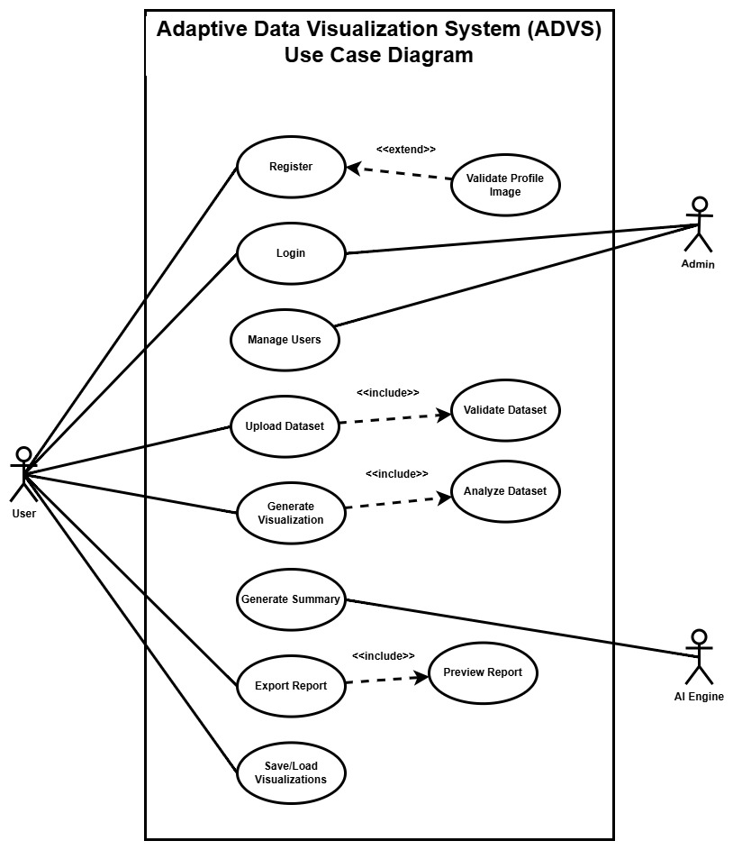
Figure 3.1: Use Case Diagram of Adaptive Data Visualization System (ADVS)
Table 3.1: Description of the Use Cases
Actor | Use Case | Description
User | Login | User logs into the system and accesses the provided services.
User | Upload dataset | User uploads CSV/XLSX/JSON file to the system, which will be validated by the system. The constraints will be file size and file type.
User | Register | User registers into the system with the option of a profile picture creation at the registration level. If the profile picture is provided, then a few validations including the type of the file (picture) is validated.
User | Generate visualization | Users generate visualization as the system will analyze the dataset and provide the users with the appropriate visualization automatically.
AI Engine | Generate summary | Uses an LLM to produce text summaries based on the data visualizations
Admin | Login | Admin logs into the system and gets redirected to the dashboard for different activities.
User | Export report | Downloads visualization along with summary as PDF or image. Also, a user can preview it before exporting.
Admin | Manage Users | Manages users into the system, performing CRUD actions.
User | Save/Load Visualization | Saves or retrieves past data analysis sessions

- Non-Functional Requirements
- Security
Only the registered user and the system admin are able to enter and update the data in the system.
- Availability
Since the system is a web application and over 15.4 million Nepalese citizens accessed the internet in 2024, according to Datareportal [6], people from most of the parts in Nepal can use it.
- Performance
The system is fast and accurate, providing fast response time to user’s requests. The system can handle different forms of exceptions that may occur within the system.
- Reliability
The system is reliable as it provides services to the users with minimal downtime.

Feasibility Study
- Technical Feasibility
The technologies required for the development of the system are readily available and open source. The programming language that was used for the development are heavily documented and has a vast collection of libraries to support.
- Operational Feasibility
The application fulfils all the requirements mentioned above and thus is operational.
- Economic Feasibility
The system was made with finances in mind. As all the necessary technologies required to develop this system were open sourced, the development cost are near about zero.

- Schedule Feasibility
The system was completed within the scheduled time. The expected time duration for the completion of the project is drawn with the help of Gantt chart, which is given below.
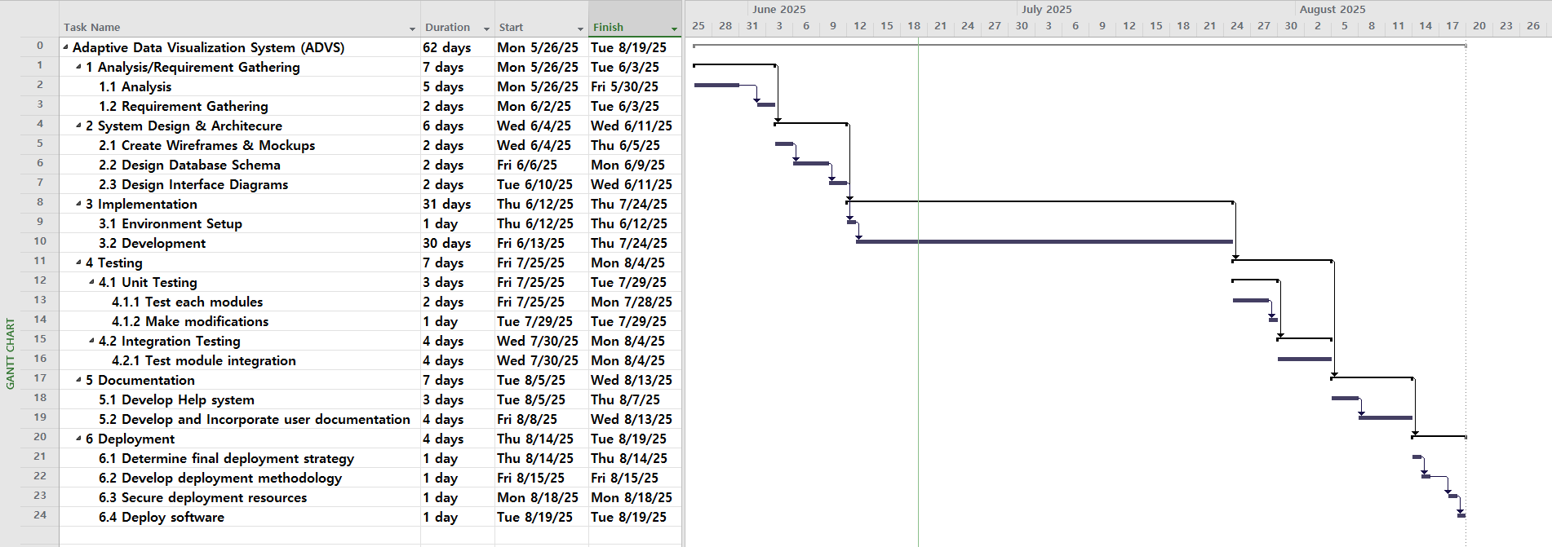
Figure 3.2: Gantt Chart of ADVS

Object Modelling: Class & Object Diagram
The class diagram represents the structural design of a data analysis and visualization system by defining its primary classes, their attributes, operations, and relationships. The User class manages authentication and provides the functionality for uploading datasets. Each uploaded dataset is modeled by the Dataset class, which stores the raw data, metadata, and summary information, and includes methods for loading and analyzing its structure. The DataProfiler class is responsible for deeper dataset analysis, including detecting data types, missing values, correlations, and generating additional metadata. To transform the analyzed data into visual form, the VisualizationEngine class selects suitable chart types and generates corresponding visualizations. The resulting visual output is represented by the Visualization class, which contains chart data, configuration details, and methods for rendering or exporting the chart. Additionally, the system includes a SummaryGenerator class that produces text-based summaries and insight prompts from processed data. Finally, the ReportExporter class consolidates the dataset, generated visualizations, and textual summaries to create exportable reports in various formats. The diagram’s associations, such as uploading, analyzing, visualizing, and generating, illustrate how these components collaborate to form a complete data-processing workflow.

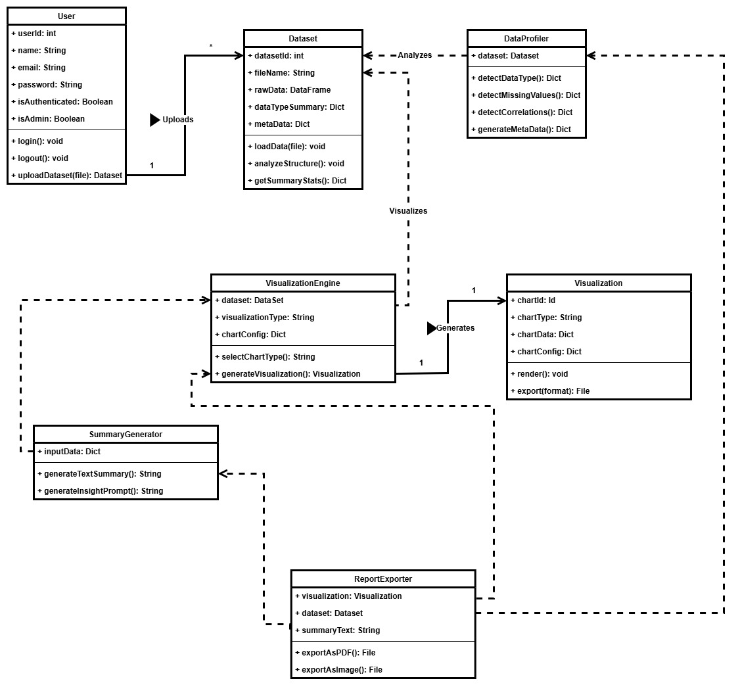
Figure 3.3: Class Diagram of ADVS
The object diagram depicts a runtime snapshot of the system, showing actual instances of classes and how they interact during a concrete execution scenario. It includes an authenticated administrative user (1) who has uploaded a dataset instance (1) representing a real file, such as “test.csv,” containing raw tabular data and associated metadata. A profiler instance (1) is linked to this dataset to extract structural characteristics and statistical information. Simultaneously, a visualization engine instance (1) is configured to create a bar chart using specific dataset attributes and chart settings. This process results in a visualization object (1), which stores the chart’s computed data and configuration. A summary generator instance (1) uses the derived metrics from the dataset to produce descriptive insights, while the report exporter instance (1) combines the dataset, visualization, and summary into a cohesive report ready for export. This object diagram highlights concrete attribute values and object interactions, demonstrating how the system behaves during a real-world task involving dataset upload, profiling, visualization creation, and report generation.

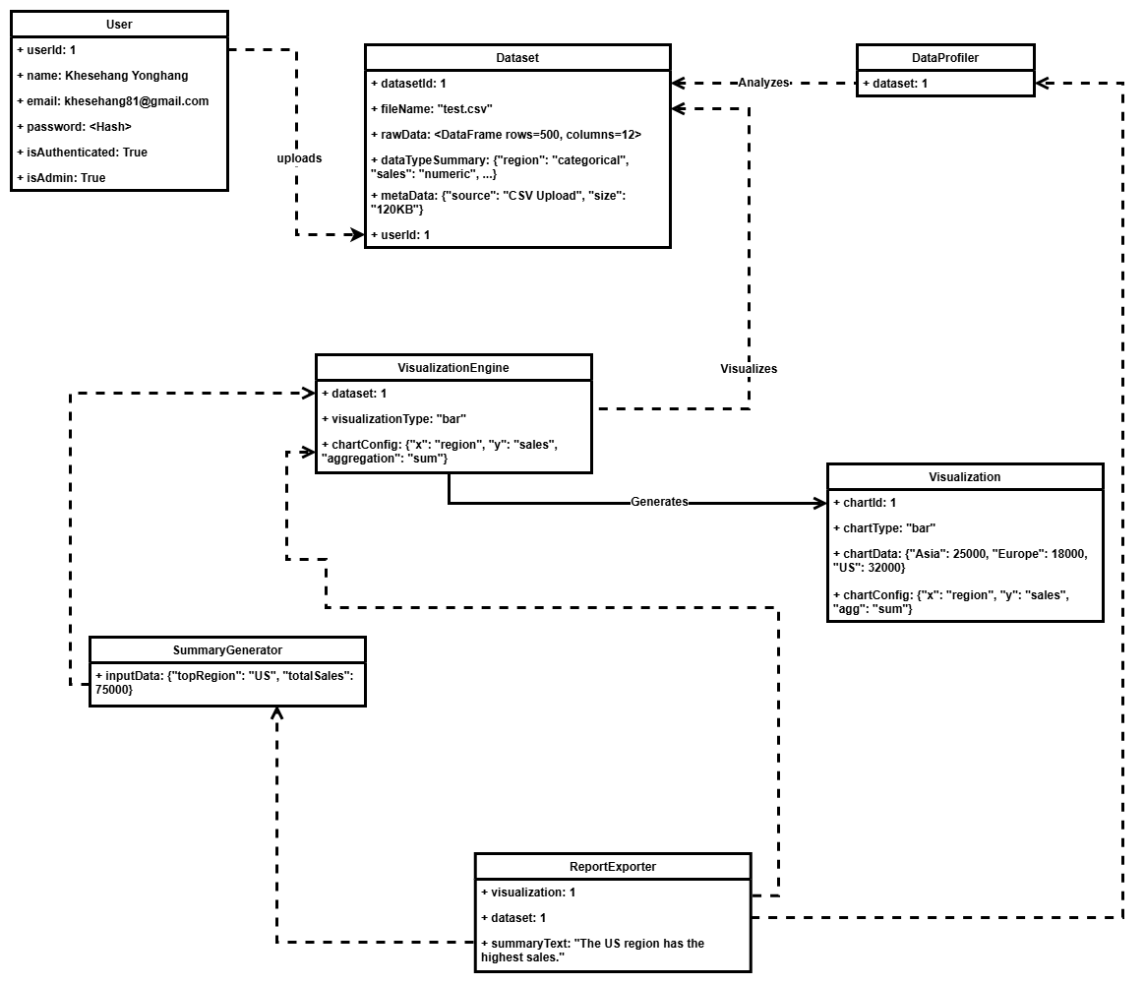
Figure 3.4: Object Diagram

Dynamic Modelling: State and Sequence Diagram
State Diagram:
The state diagram describes the operational lifecycle of the system as it moves through various stages based on user actions and internal processing. The system begins in the authentication state, transitioning to dataset upload once the user is verified. Upon receiving a valid dataset, the system enters the data profiling state, where it sequentially detects data types, missing values, correlations, and generates metadata. After profiling is complete, the system advances to the visualization selection state, where users may either rely on the machine learning model for automatic chart recommendations or manually choose a visualization type. The chosen chart is then generated and rendered in the visualization state. If users request a summary, the system enters the summary generation state, producing text summaries and insights based on the visualization results. Finally, the system moves into the reporting state, where users can export their results as PDF or image files before returning to the dashboard or logging out. This diagram effectively showcases the structured flow of states that guide the system from data input to final export.
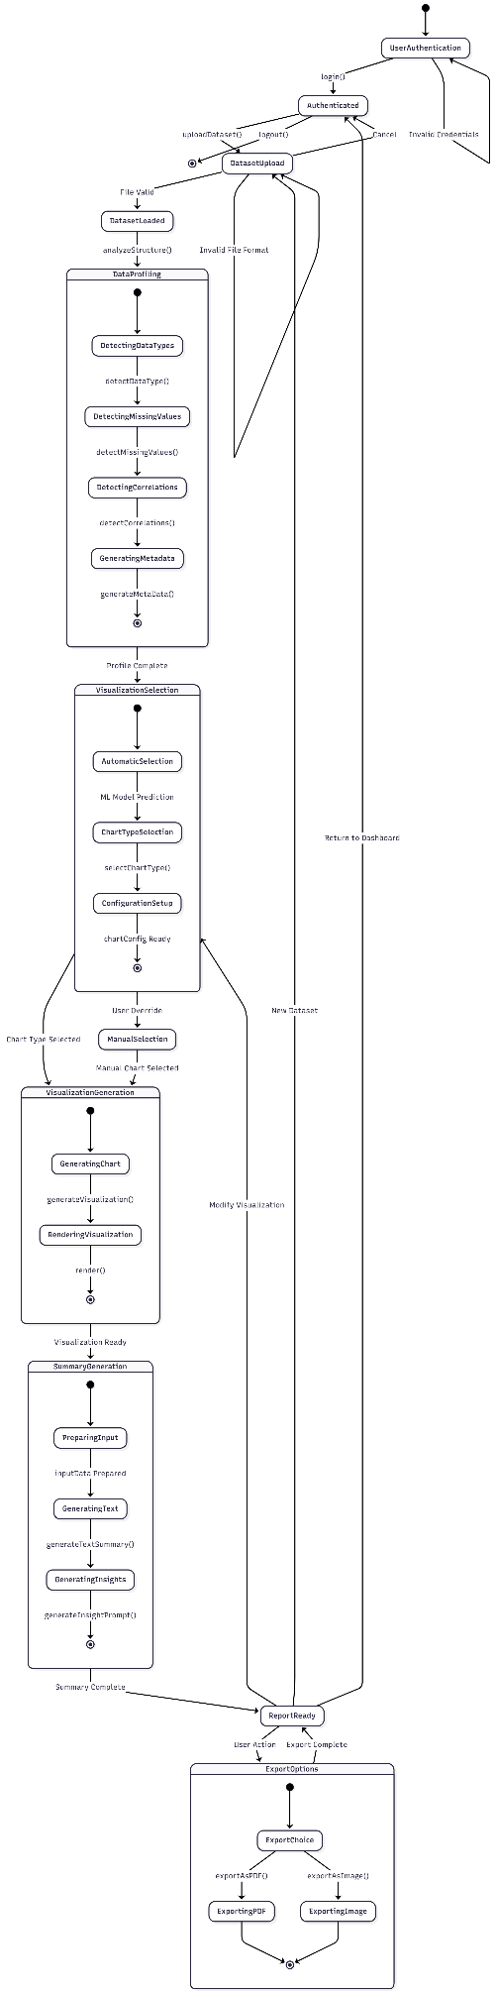
Figure 3.5: State Diagram of ADVS
Sequence Diagram
The sequence diagram illustrates the complete workflow of the Adaptive Data Visualization System, showing how each component interacts from the moment a user logs in until the final report is generated. After successful authentication, the user uploads a dataset, which is then analyzed by the DataProfiler to identify data types, missing values, correlations, and other structural details. This metadata is passed to the machine learning module, where a Random Forest Classifier combined with a MultiOutput Classifier predicts the most suitable chart types for the dataset. The VisualizationEngine then configures and generates the corresponding visualization, which is rendered for the user. If desired, the user can request a summary, prompting the system to send prepared data to the LLaMA-based summarization module, which returns concise textual explanations and insights. Finally, the user can export the visualization and summary in PDF or image format using the ReportExporter, completing the workflow before logging out. Overall, the diagram captures the coordinated interactions among authentication, data processing, machine learning, visualization rendering, language generation, and reporting modules.
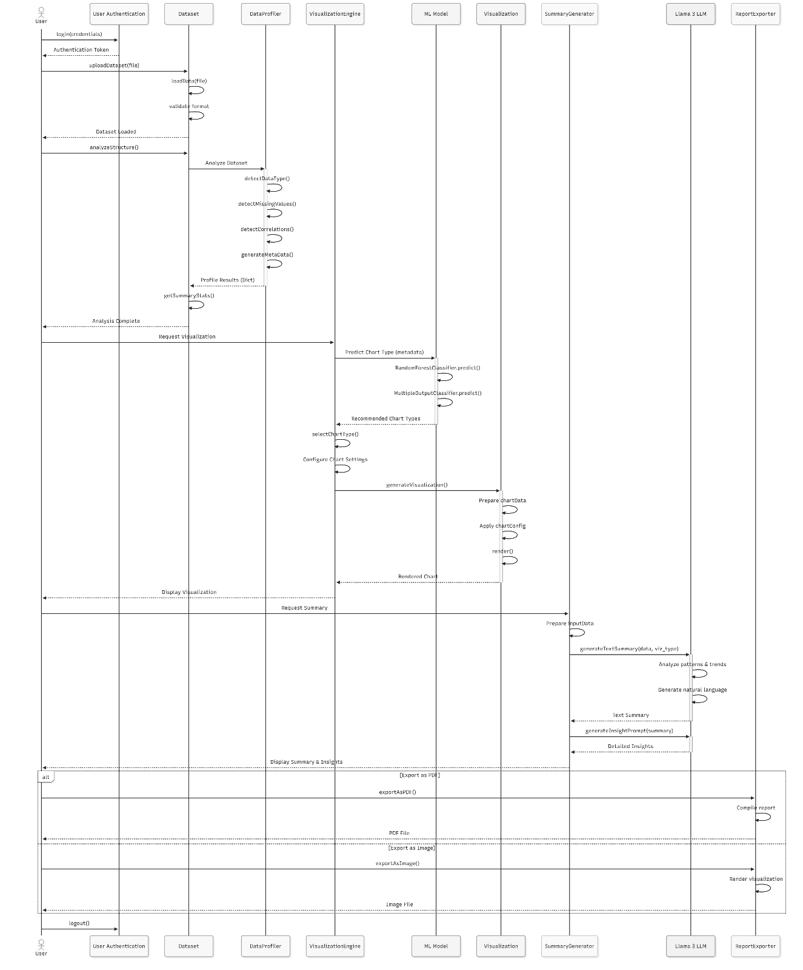
Figure 3.6: Sequence Diagram of ADVS

Process Modelling: Activity Diagram
The activity diagram outlines a complete end-to-end workflow for a user interacting with a data-analysis platform. It begins with user authentication, where the system verifies login credentials and either grants access to the dashboard or loops the user back to retry. Once authenticated, the user uploads a dataset, and the system checks whether the file format is valid. Invalid files prompt the user to upload again, while valid ones proceed into the loading and preprocessing stages.
After loading the dataset, the platform performs a detailed data-profiling sequence. This step is executed partly in parallel and includes detecting data types, identifying missing values, finding correlations, and generating metadata. Once all profiling tasks complete and converge, the user is asked whether they want the system to automatically determine the best visualization or manually select one. Automatic selection uses machine-learning models, including RandomForest and ClassifierChain, while the manual path lets the user pick the chart type themselves.
Both paths lead into visualization setup, where the user configures parameters and the system renders the final visualization. Following this, a summary of the visualization is generated by calling a local Llama LLM server. The platform then displays the visualization along with the generated insights, giving the user several possible next actions. The user can export the output as a PDF or image, upload a new dataset and restart the workflow, modify the visualization by returning to the chart selection phase, or simply log out. The process concludes once the user chooses to exit the system.
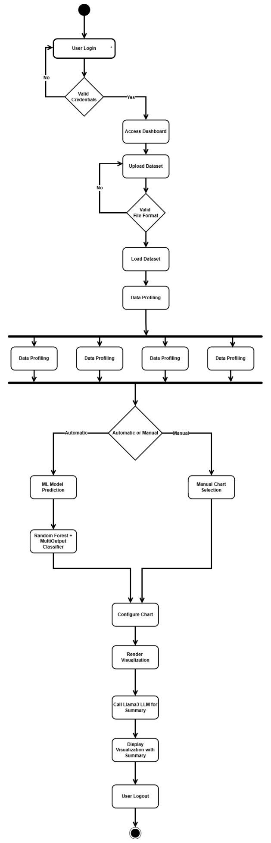
Figure 3.7: ADVS Activity Diagram

System Design

Refinement of Classes and Objects
The class diagram represents a complete data-analysis and visualization platform that integrates dataset management, automated profiling, machine-learning–driven chart selection, visualization rendering, AI-generated summaries, and reporting/exporting tools. At the core of the system is the User class, which handles authentication, session creation, dataset uploads, and dataset history management. Each user is associated with a SessionManager instance to track login status and session activity, ensuring secure and continuous user interactions.
Uploaded datasets are represented by the Dataset class, which stores raw data along with metadata, summary statistics, and structural information. Two major subsystems depend on this class: the DataProfiler, which analyzes the dataset to detect data types, missing values, correlations, and outliers, and the VisualizationEngine, which evaluates dataset features, selects suitable chart types (automatically or manually), and produces visualization objects. The VisualizationEngine works closely with the MLClassifier, which is composed of both a RandomForestClassifier and a ClassifierChain, enabling machine-learning-based recommendations for the most appropriate visual representation based on dataset characteristics.
Every generated visualization is encapsulated in the Visualization class, which holds chart data, configuration details, and rendering behavior. To enhance interpretability, each visualization can be passed to a SummaryGenerator, which formats input data and interacts with a LlamaClient to generate textual summaries and key insights using a local LLM. These summaries, together with the visualization and dataset, can then be transformed into professional reports through the ReportExporter, which supports exporting in multiple formats, PDF, images, or HTML, and allows customization such as templates and watermarks.
Supporting these high-level operations is the FileManager, which handles storage, retrieval, validation, and metadata access for files across the system. It ensures that uploaded datasets, generated visualizations, and exported reports are correctly maintained. Overall, the class diagram outlines a robust and modular architecture where each component plays a specific role, and dependencies are clearly organized to support a seamless workflow from dataset upload through visualization, AI-powered summarization, and final report generation.
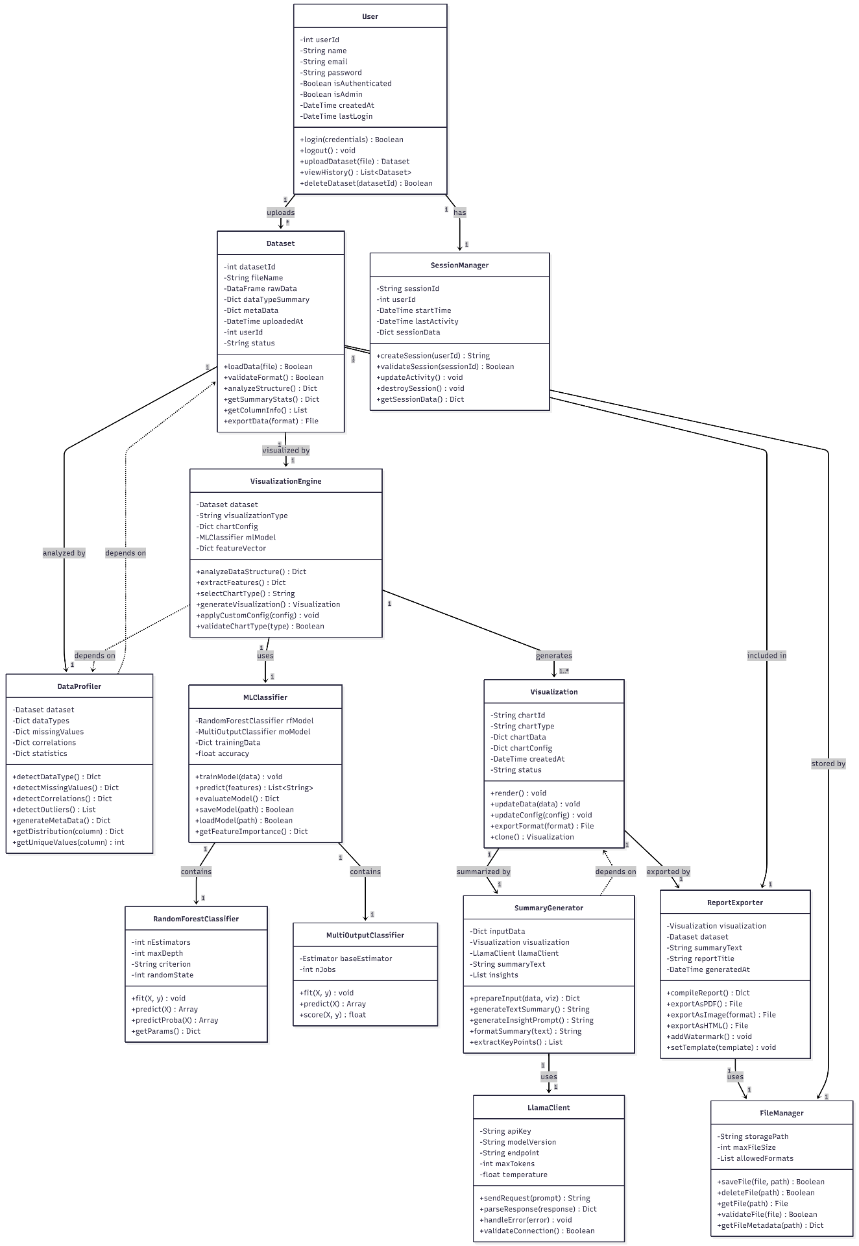
Figure 3.8: Refinement of Class Diagram
The object diagram presents a runtime snapshot of a user named Alice Smith (User 101) who is actively generating a sales report using the system. Alice is authenticated, has a valid session managed by a SessionManager instance, and her session reflects recent activity. She has uploaded a dataset called Q3_Sales.csv (Dataset 500), containing 15,000 rows and 10 columns, which is marked as ready for analysis and linked directly to her user account.
Once uploaded, the dataset undergoes automated analysis through a DataProfiler instance, which has extracted structural insights such as data types, missing values, and correlation relationships, most notably a strong correlation between ad spend and revenue. These profiling results flow into the VisualizationEngine, which is configured for predictive analytics and uses a feature vector derived from sales and monthly data. The engine relies on an associated MLClassifier, which in turn wraps a trained RandomForestClassifier model with 100 estimators and an accuracy of 94%. This ML pipeline assists the system in selecting or validating appropriate visualization types.
The engine produces a rendered visualization represented by a Visualization instance (viz_999), specifically a bar chart that has been fully processed and stored with its configuration and data points. This chart is then passed to a SummaryGenerator, which compiles contextual information and sends a prepared prompt to a LlamaClient instance configured to interact with a Llama-2 model. The result is a generated summary highlighting key insights such as a 15% increase in Q3 revenue and notable positive trends.
Finally, the system prepares a full analytical report using a ReportExporter instance, which incorporates the chart, dataset context, and generated summary. This report is saved through a FileManager instance pointing to storage on an S3 bucket, with defined constraints on file size and supported formats like PDF, PNG, and HTML. Overall, this object diagram captures a cohesive moment in the workflow where Alice has successfully uploaded a dataset, analyzed it, generated a visualization, produced AI-driven insights, and prepared a comprehensive report for export.
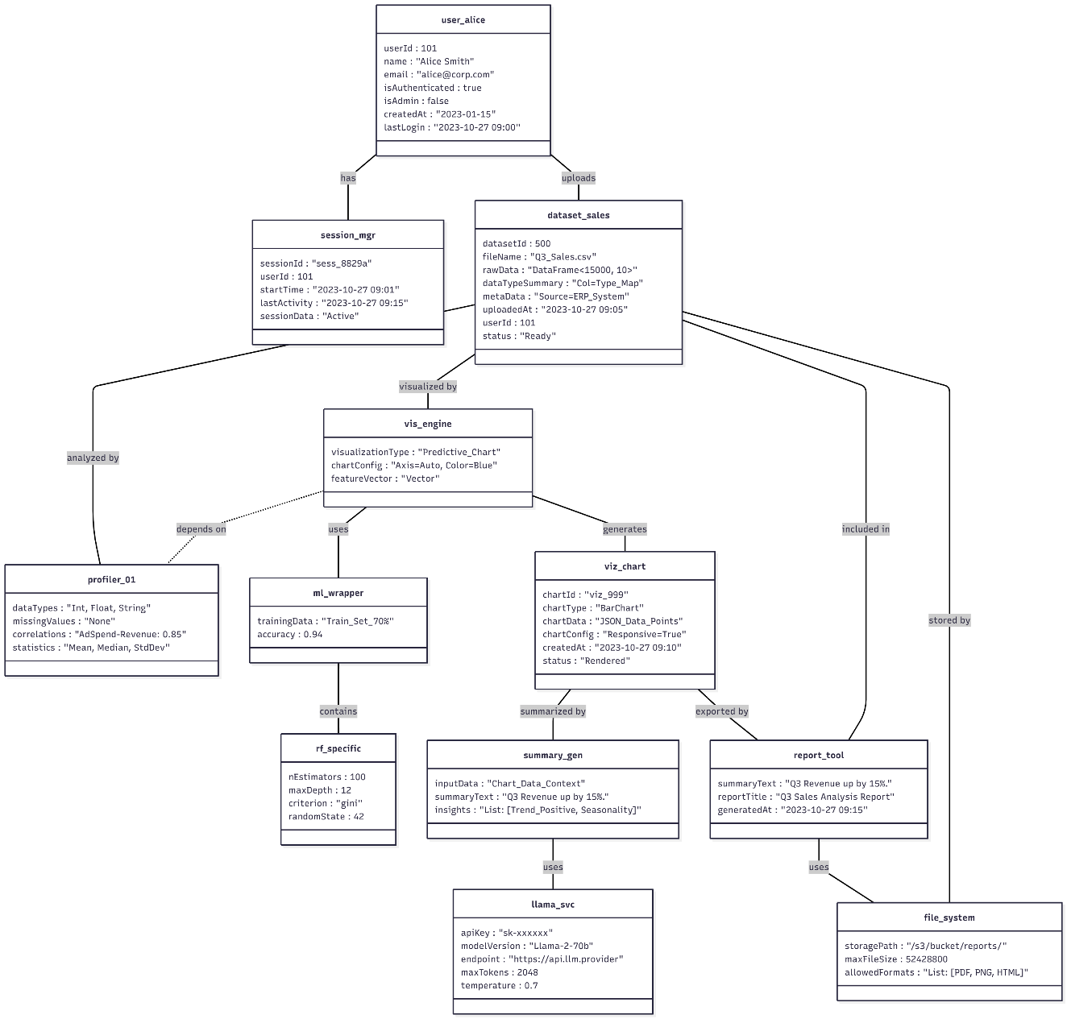
Figure 3.9: Refinement of Object Diagram

Component Diagram
The component diagram shows how the major logical modules of ADVS interact. It includes components for User Management, Dataset Management, ML Recommendation, Visualization, and an external LLM component. Data flows between components are labeled: users upload datasets to Dataset Management, which exposes a dataset accessor to the LLM; the ML Recommendation component receives feature selections and returns chart recommendations; and the Visualization component consumes chart data to produce visual output. Overall, the diagram highlights the functional structure of the system and how each subsystem collaborates to generate insights and visualizations.
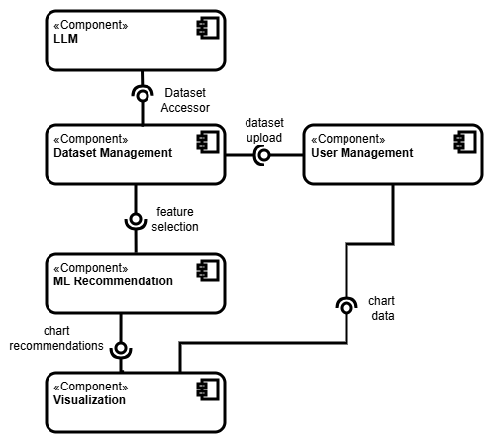
Figure 3.10: Component Diagram for ADVS

Deployment Diagram
The deployment diagram illustrates the physical architecture of ADVS across servers. A Client Device (browser) communicates with an Nginx Server, which routes requests to the Django Web Server hosting the application logic. A Database Server stores both user records and datasets. A separate LLM Server hosts the Ollama-based LLM gateway for summarization and AI tasks. The diagram clearly separates concerns across infrastructure layers: frontend, backend, database, and AI services.
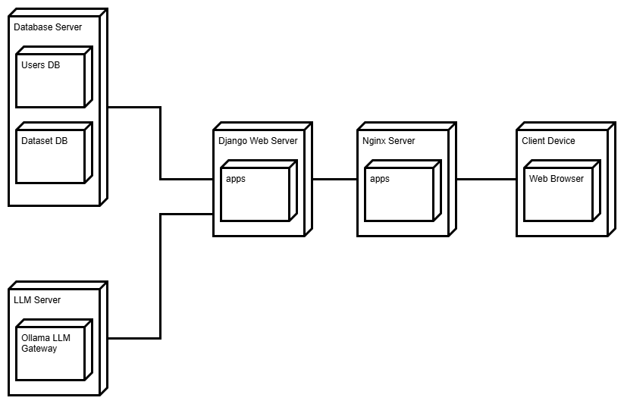
Figure 3.11: Deployment Diagram of ADVS

Algorithm
In ADVS, the following algorithms are used.
- Forward Chaining algorithm is used to infer data type in the system:
Forward chaining is a type of reasoning in which atomic clauses in a knowledge base are used to retrieve more data in the forward path using inference principles (Modus Ponens).
Before deriving new information, the inference engine evaluates current data, derivations, and conditions in this sort of chaining. The manipulation of information in the knowledge base results in the achievement of an objective (goal). [7]
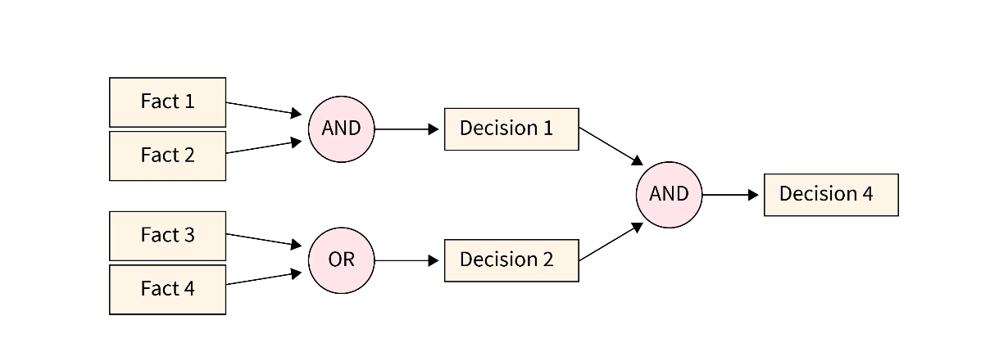
Figure 3.12: Forward Chaining Algorithm Example
Given:
- A Knowledge Base (KB) containing Horn clauses in First-Order Logic (FOL).
- A query q (a ground atomic goal).
Determine whether q logically follows from KB: KB ⊨ q
Definitions:
- A Horn clause in FOL is of the form:
(p1 ∧ p2 ∧ ... ∧ pn) → q
where p_i, q are atomic formulas (possibly with variables).
- Facts are ground atoms (no variables) in the KB.
- Inference Rule: A rule with variables that can be instantiated via unification.
Algorithm (Forward Chaining in FOL):
1. Initialize known facts set: C ← all ground atomic facts in KB
2. Repeat:
a. For each rule r: (p1 ∧ p2 ∧ ... ∧ pn) → q in KB:
i. For each substitution θ such that:
{p1θ, p2θ, ..., pnθ} ⊆ C (i.e., all premises match known facts)
ii. Let qθ be the inferred conclusion.
iii. If qθ ∉ C:
Add qθ to C
If qθ == query:
Return SUCCESS
3. If no new facts are inferred:
Return FAILURE
Explanation:
The algorithm searches for applicable rules whose premises match current facts (via unification). When a rule fires, it infers a new fact by applying the rule's conclusion with the substitution. It continues until no more facts can be added, or the query is derived.
Complexity:
Let:
- n: number of facts inferred
- m: number of rules
- k: average number of premises per rule
- u: time for unification
Time Complexity:
Worst-case time complexity:
O(n * m * k * u)
Each fact may trigger many rules, each rule needs multiple unifications, unification time u can be O(t), where t is the size of the terms.
Space Complexity:
Worst-case space complexity:
O(n * t + m * k)
Where, t is the average size of terms involved in substitutions
You must store:
- All inferred ground facts: up to O(n)
- All rules and clauses: O(m * k)
- Substitutions and intermediate mappings: up to O(n * t)
- The combination of Random Forest Classifier and Classifier Chain algorithms are used for visualization selection logic
A Random Forest is an ensemble of decision trees that works using the principle of bagging (Bootstrap Aggregation).
How it works
- From the full dataset D, it creates multiple bootstrap samples
D1,D2,…,DT
by sampling with replacement.
- For each sample, it trains a Decision Tree.
At each split, instead of considering all features, it selects a random subset of features, which introduces diversity among trees.
- To classify a new instance x, each tree gives a prediction:
h1(x),h2(x),…,hT(x)
- The final prediction is made by majority voting (classification):
y=mode(h1(x), h2(x) ,…hT(x))
Mathematical Significance
Random Forest reduces two critical issues of decision trees:
Variance Reduction
One decision tree has high variance. By combining multiple trees:
Var(average of models)=Var(single model)/T
Correlation Reduction
Random feature selection reduces correlation between trees:
$\text{Var(Forest)}=\frac{σ^{2}}{T}\left(1+\left(T-1\right)ρ\right)$
where
- $ρ$= correlation between trees
- lower $ρ$ ⇒ better performance
A MultiOutput Classifier is not a new model, but a strategy. It takes a base classifier (e.g., Random Forest Classifier) and duplicates it for each output.

IMPLEMENTATION AND TESTING

Implementation

Tools Used
Frontend
- HTML
HTML will be used to provide the structure to the overall system. It will be the foundation of the system and lay the ground works for the overall design implementation.
- CSS (Tailwind)
With the structure in place, CSS will be responsible for the overall look and feel of the system. Tailwind library will be used to enhance the development pace with a modern look and feel.
- JavaScript (HTMX)
For the behavioral side of things, JavaScript will be responsible. To communicate asynchronously with the backend, a small and lightweight library HTMX will be used. The library will be used to make the UX smoother and users focused on the system.
Backend
- Python (dJango)
To handle the business logic of the overall system, dJango, a web framework created over the Python programming language, will be used. Other packages compatible with the framework found in Pip, including django-allauth for authentication and authorization, pyscopg2 for connecting to the Postgres database, and etc. will be used in conjunction with the framework to complete the business logic.
- Ollama with Open Source LLMs for Summary Generation
For generating the summaries of the visualizations, a small LLM will be used using Meta’s Ollama. The LLM will be integrated with the dJango backend to provide a good user experience.

Database
- PostgresSQL
Since, PostgreSQL is an open source and widely adopted database, which integrates well with the dJango framework, it will be used in the system. It will be used to store the data that will be created by the user, including the user details.

Implementation Details of Modules
User Authentication Module
Manages user registration, login, logout, and session management. This module handles password encryption, token generation for authenticated sessions, and role-based access control (admin vs regular users). It ensures secure access to the system and maintains user session states throughout their interaction with the application. Django Allauth is the backbone of this module.
Dataset Upload Module
Handles file upload functionality, accepting datasets CSV. This module validates file formats, checks file size constraints, parses uploaded files into DataFrames, and stores them in the file system. It also manages dataset metadata including filename, upload timestamp, and user ownership.
Data Profiling Module
Analyzes uploaded datasets to extract comprehensive statistical and structural information. This module detects data types (numerical, categorical, temporal, boolean), identifies missing values, calculates summary statistics (mean, median, mode, standard deviation), detects correlations between variables, identifies outliers, and generates metadata that describes the dataset's characteristics for downstream processing.
Code Snippet:
def profile(self, df: pd.DataFrame) -> Dict:
"""
Generate comprehensive profile of a DataFrame.
Parameters
----------
df : pd.DataFrame
Input DataFrame to profile
Returns
-------
Dict
Complete profile including dataset overview, column statistics,
correlations, relationships, and chart recommendations
"""
total_rows = len(df)

result = {
"dataset_overview": {
"rows": total_rows,
"columns": len(df.columns),
"memory_mb": round(df.memory_usage(deep=True).sum() / 1_000_000, 3),
"duplicate_row_percent": float(df.duplicated().mean() * 100),
"missing_overall_percent": float(df.isna().mean().mean() * 100),
"is_wide": len(df.columns) > total_rows,
"density": float(total_rows * len(df.columns))
},
"column_type_summary": {
"numeric_count": 0,
"categorical_count": 0,
"datetime_count": 0,
"text_count": 0
},
"columns": [],
"correlations": [],
"correlation_analysis": {},
"hierarchical_analysis": {},
"pairwise_relationships": [],
"representative_rows": [],
"chart_hints": {}
}

# Profile each column
for col in df.columns:
s = df[col]
info = {
"name": col,
"missing_percent": float(s.isna().mean() * 100),
}

if pd.api.types.is_bool_dtype(s):
info.update(self._profile_categorical(s, total_rows))
result["column_type_summary"]["categorical_count"] += 1
elif pd.api.types.is_numeric_dtype(s):
info.update(self._profile_numeric(s, total_rows))
result["column_type_summary"]["numeric_count"] += 1
elif pd.api.types.is_datetime64_any_dtype(s):
info.update(self._profile_datetime(s, total_rows))
result["column_type_summary"]["datetime_count"] += 1
else:
if s.nunique() < 50:
info.update(self._profile_categorical(s.astype(str), total_rows))
result["column_type_summary"]["categorical_count"] += 1
else:
info.update(self._profile_text(s.astype(str), total_rows))
result["column_type_summary"]["text_count"] += 1

info["flags"] = self._detect_flags(s, total_rows)
result["columns"].append(info)

# Correlation matrix (limited to prevent performance issues)
numeric_df = df.select_dtypes(include=["number"])
if 2 <= numeric_df.shape[1] <= self.max_corr_columns:
try:
with warnings.catch_warnings():
warnings.simplefilter("ignore")
corr = numeric_df.corr().stack().reset_index()
corr.columns = ["col1", "col2", "correlation"]
corr = corr[corr["col1"] < corr["col2"]]
result["correlations"] = corr.to_dict(orient="records")
except Exception as e:
self._log(f"Correlation matrix computation failed: {e}")
result["correlations"] = []

# Advanced analyses
result["correlation_analysis"] = self._analyze_correlation_strength(df)
result["hierarchical_analysis"] = self._detect_hierarchical_structure(df)
result["pairwise_relationships"] = self._analyze_pairwise_relationships(df)
result["representative_rows"] = self._representative_rows(df)
result["chart_hints"] = self._generate_chart_hints(result)

# Add univariate chart suggestions to each column
for col_profile in result["columns"]:
col_name = col_profile["name"]
dtype = col_profile["dtype"]
charts = []

if dtype == "numeric":
if self._has_non_trivial_numeric([col_profile]):
charts.extend(["histogram", "boxplot"])
elif dtype == "categorical":
card = col_profile.get("cardinality", {})
if card.get("is_suitable_for_pie"):
charts.extend(["pie", "bar"])
elif card.get("is_suitable_for_bar"):
charts.append("bar")

col_profile["suggested_univariate_charts"] = charts
return result
Visualization Engine Module
Core module responsible for chart selection and visualization generation. It extracts relevant features from profiled data, interfaces with the ML Classifier to predict appropriate chart types, configures visualization parameters based on data characteristics, and generates various chart types including bar charts, line graphs, scatter plots, pie charts, histograms, and correlation heatmaps.
Code Snippet:
def recommend(self, profile: Dict, top_k: int = 3) -> List[Dict]:
"""
Generate top k recommendations with detailed analysis
:param profile:
:param top_k:
:return: A list of recommendations[Dict]
"""
chart_hints = profile.get("chart_hints", {})
suitable_charts = chart_hints.get("suitable_charts", [])

if not suitable_charts:
suitable_charts = self._get_fallback_charts(profile)

ranked_charts = self._rank_charts(profile, suitable_charts[:5])

return ranked_charts

ML Classifier Module
Implements machine learning models for intelligent chart type recommendation. This module uses a Random Forest Classifier combined with Classifier Chain to predict the most suitable visualization types based on dataset features.
Code Snippet
@shared_task
def analyze_dataset_task(dataset_id):
dataset = DatasetUploadModel.objects.get(id=dataset_id)
service = VisualizationService()

try:
dataset.status = StatusChoices.PENDING
dataset.save(update_fields=['status'])

recommendations = service.generate_recommendations(dataset)

dataset.top_candidate_charts = convert_numpy(recommendations)
dataset.status = StatusChoices.COMPLETED
dataset.save(update_fields=['top_candidate_charts', 'status'])

except Exception as e:
dataset.status = StatusChoices.FAILED
dataset.save(update_fields=['status'])
raise
Random Forest Classifier Component
Implements the ensemble learning algorithm using multiple decision trees. This component provides robust classification for chart type prediction by aggregating predictions from numerous decision trees, reducing overfitting, and handling non-linear relationships in data characteristics. It supports hyperparameter tuning (number of estimators, max depth, criterion) for optimal performance.
Code Snippet:
clf = ClassifierChain(
RandomForestClassifier(n_estimators=100, max_depth=20, random_state=42, n_jobs=-1),
order='random',
random_state=42
)
Classifier Chain Component
Wraps the Random Forest classifier to handle multiple output predictions simultaneously. This enables the system to recommend multiple suitable chart types ranked by appropriateness, allowing users to choose from top recommendations rather than a single prediction. It manages parallel prediction tasks efficiently.
Summary Generator Module
Creates natural language explanations of visualizations using AI. This module prepares input data by extracting key patterns, trends, and statistics from visualizations, constructs prompts for the language model, interfaces with the Llama 3 API, parses responses, and generates human-readable summaries that describe what the visualization shows, including trends, correlations, outliers, and actionable insights.
Code Snippet:
class SummaryConsumer(AsyncWebsocketConsumer):

async def connect(self):
await self.accept()

async def disconnect(self, close_code):
pass

async def receive(self, text_data):
data = json.loads(text_data)
pk = data.get("pk")
await self.stream_llm(pk)

async def stream_llm(self, pk):
dataset = await sync_to_async(DatasetUploadModel.objects.get)(pk=pk)

df_head = await sync_to_async(lambda: dataset.get_df.head(20).to_csv(index=False))()

payload = {
"model": LLM_LLAMA,
"prompt": LLM_DATASET_SUMMARY_PROMPT_STREAM.format(data_head=df_head),
"stream": True,
}

async with httpx.AsyncClient(timeout=None) as client:
async with client.stream(
"POST",
LLM_API_ENDPOINT,
json=payload,
) as response:

full = []

async for line in response.aiter_lines():
if not line:
continue

try:
chunk = json.loads(line)
print(chunk)
token = chunk.get("thinking") or chunk.get("response") or ""
except:
token = line

full.append(token)

await self.send(json.dumps({"token": token}))

summary = "".join(full)
dataset.summary = summary
await sync_to_async(dataset.save)()

await self.send(json.dumps({"done": True}))
Llama 3 Integration Module
Manages communication with the Llama 3 large language model API. This module handles API authentication, request formatting, error handling and retries, response parsing, and rate limiting. It abstracts the complexity of LLM interaction, providing a clean interface for the Summary Generator to request text generation services.
Visualization Rendering Module
Handles the actual rendering of charts and graphs. This module takes chart specifications (type, data, configuration) and generates visual representations using the Plotly charting library. It manages chart styling, axis configuration, legends, colors, and responsive design to ensure visualizations are clear and professional.
Model Training Module
Handles retraining and updating of ML models. This module collects user feedback on visualization recommendations, prepares training datasets from historical data, implements model training pipelines, evaluates model performance metrics, versions and deploys updated models, and implements A/B testing for model improvements.

Testing

Test Cases for Unit Testing
Table 4.1: Unit Tests for Authentication Module
Test Case ID | Description | Input Test Data | Expected Result | Actual Result | Pass/Fail
TC 1 | Valid user login | Username: "john@example.com"  Password: "Pass123!" | User should be authenticated successfully. | User authenticated successfully | Pass
TC 2 | Invalid password login | Username: "john@example.com"  Password: "WrongPass" | Login should be failed, error message: "Invalid credentials" | Login failed, error message “Invalid Credentials” shown | Pass
TC 3 | Non-existent user login | Username: "fake@example.com"  Password: "Pass123!" | Login should fail, error message: "User not found" | Login failed, “User not found” shown | Pass
TC 4 | Empty credentials | Username: ""  Password: "" | Validation error: "Username and password required" | Validation error “Username and password required” shown | Pass
TC 5 | Password encryption | Plain text password: "Test123!" | Password should be hashed using django’s default hashing algorithm, not stored as plain text | Hashed password was saved, not the plain text. | Pass

Table 4.2: Unit Tests for Dataset Upload Module
Test Case ID | Description | Input Test Data | Expected Result | Actual Result | Pass/Fail
TC 1 | Valid CSV upload | File: "sales_data.csv" (5KB, valid format) | File should upload successfully, successful message should show. | File uploaded successfully, successful message should shown. | Pass
TC 2 | Invalid file format | File: "document.pdf" (2KB) | Should reject upload, error: "Unsupported file format" | Upload Rejected, error message shown. | Pass
TC 3 | Oversized file | File: "large_data.csv" (100MB) | Should reject upload, error: "File size exceeds limit" | Upload Rejected, error message shown | Pass
TC 4 | File name validation | File: "../../../etc/passwd" | Should sanitize filename, prevent security vulnerability | Filename sanitized; security vulnerability prevented | Pass
TC 5 | Duplicate file upload | Same file uploaded twice | Accept both uploads, assign unique dataset IDs | Duplicate file accepted with another unique id. | Pass

Table 4.3: Unit Tests for Data Profiling Module
Test Case ID | Description | Input Test Data | Expected Result | Actual Result | Pass/Fail
TC 1 | Detect numerical data type | Column: [1, 2, 3, 4, 5] | Detect Data type as "numerical" | Detected numerical data type | Pass
TC 2 | Detect categorical data type | Column: ["Red", "Blue", "Green", "Red"] | Detect Data type as "categorical" | Data type detected as "categorical" | Pass
TC 3 | Detect temporal data type | Column: ["2024-01-01", "2024-01-02"] | Detect Data type as "temporal" | Data type detected as "temporal" | Pass
TC 4 | Detect boolean data type | Column: [True, False, True, False] | Detect Data type as "boolean" | Data type detected as "boolean" | Pass
TC 5 | Detect missing values | Column: [1, 2, NaN, 4, NaN] | Detect missing values count: 2; percentage: 40% | Missing values count: 2, percentage: 40% | Pass
TC 6 | Calculate summary statistics | Column: [10, 20, 30, 40, 50] | Result should be:  Mean: 30, Median: 30, Std: 15.81, Min: 10, Max: 50 | Mean: 30, Median: 30, Std: 15.81, Min: 10, Max: 50 | Pass
TC 7 | Detect correlation | Columns: X=[1,2,3,4], Y=[2,4,6,8] | Correlation coefficient should be 1.0 (perfect positive) | Correlation coefficient: 1.0 (perfect positive) | Pass
TC 8 | Detect outliers | Column: [10, 12, 11, 10, 100, 9] | Detect Outlier | Outlier detected: 100 | Pass

Table 4.4: Unit Tests for ML Classifier Module
Test Case ID | Description | Input Test Data | Expected Result | Actual Result | Pass/Fail
TC 1 | Predict chart for numerical data | Features: [2, 0, 0, 0, 1] (2 numerical cols) | Recommend chart: "scatter" or "line" | Recommended chart: "scatter" or "line" | Pass
TC 2 | Predict chart for categorical data | Features: [0, 1, 0, 0, 0] (1 categorical col) | Recommend chart: "bar" or "pie" | Recommended chart: "bar" or "pie" | Pass
TC 3 | Predict chart for time series | Features: [1, 0, 1, 0, 0] (1 numerical, 1 temporal) | Recommend chart: "line" | Recommended chart: "line" | Pass
TC 4 | Predict chart for correlation | Features: [2, 0, 0, 0, 1] (2 numerical, high correlation) | Recommend chart: "scatter" or "heatmap" | Recommended chart: "scatter" or "heatmap" | Pass
TC 5 | Model prediction accuracy | Test dataset: 100 samples | Prediction accuracy should be greater than 85% | Prediction accuracy > 85% | Pass
TC 6 | Multiple output prediction | Features: [3, 1, 0, 0, 0] | Should return top 3 recommendations with confidence scores | Top 3 recommendations returned with confidence scores | Pass
TC 7 | Load pre-trained model | Model file: "rf_model.pkl" | Should load model for prediction. | Model loaded successfully, ready for prediction | Pass
TC 8 | Save trained model | Trained model object | Should save model saved to file; should have file size > 0 bytes | Model saved to file, file size > 0 bytes | Pass
TC 9 | Feature importance retrieval | Trained model | Should return feature importance scores for all features | Feature importance scores returned for all features | Pass

Table 4.5: Unit Tests for Summary Generation Module
Test Case ID | Description | Input Test Data | Expected Result | Actual Result | Pass/Fail
TC 1 | Generate text summary | Visualization data + metadata | Should generate a summary of about 50 to 200 words. | Summary text generated (50-200 words) | Pass
TC 2 | Handle Llama 3 API error | API returns error code 500 | Should handle error and provide the summary with a fallback. | Error handled gracefully, fallback summary provided | Pass
TC 3 | Format summary output | Raw LLM response with JSON | Should handle the JSON output to show human readable summary. | Summary formatted as plain text. | Pass
TC 4 | Prepare input for LLM | Dataset metadata + viz config | Should properly format the JSON input for the LLM. | JSON prompt formatted correctly | Pass
TC 5 | Parse LLM response | JSON response from API | Text should be extracted and cleaned. | Text extracted and cleaned | Pass
TC 6 | Timeout handling | API response time > 30s | Should output the timeout error message after 3 (default) unsuccessful attempts. | Request timeout, error message returned after 3 (default) unsuccessful attempts/ | Pass

Test Cases for System Testing
Table 4.6: End-to-End Workflow Test
Test Case ID | Description | Input Test Data | Expected Result | Actual Result | Pass/Fail
TC 1 | Complete user workflow | Login → Upload CSV → View auto viz → Export PDF | User should complete all steps, and PDF should download successfully | User completes all steps, PDF downloaded successfully | Pass
TC 2 | Multiple dataset workflow | Upload datasets → Generate viz for each → Compare results | 3 visualizations should be generated and displayed side-by-side | 3 visualizations generated, displayed side-by-side | Pass
TC 3 | Multiple Contexts | User A uploads dataset → uploads contexts→ gets viz tailored to the contexts | Viz should be tailored to the user’s contexts. | Viz obtained is tailored as per the user’s contexts. | Pass

Table 4.7: Integration Test
Test Case ID | Description | Input Test Data | Expected Result | Actual Result | Pass/Fail
TC 1 | Database integration | Save user data → Query database → Verify data | Data should persist correctly in PostgreSQL | Data persisted correctly in PostgreSQL | Pass
TC 2 | Llama 3 API integration | Send prompt → Receive response | API call should be successful and, summary text should be returned | API call successful, summary text returned | Pass
TC 3 | ML model integration | Load model → Make prediction → Return result | Model should make accurate predictions and fast (<2s) | Model predictions accurate and fast (<2s) | Pass
TC 4 | File storage integration | Upload file → Store to disk → Retrieve file | Files should be stored and retrieved without corruption | Files stored and retrieved without corruption | Pass

Result Analysis

Evaluating Accuracy
The accuracy evaluation of the machine learning model in the Adaptive Data Visualization System (ADVS) is crucial to ensure reliable and appropriate chart recommendations.
Dataset Preparation
The training dataset was compiled from 20 diverse CSV files collected from publicly available sources on the open web, spanning multiple domains including business, healthcare, education, finance, environmental science, and social demographics. This multi-domain approach ensures the model can handle datasets with varying characteristics and structures commonly encountered in real-world scenarios.
Dataset Sources:
- Kaggle public datasets
- Government open data portals (data.gov, WHO, World Bank)
- UCI Machine Learning Repository
- Google Dataset Search
- Domain-specific public repositories
Dataset Characteristics:
- Total number of CSV files: 20
- Domain diversity: 8+ different domains
- Size range: Small (50 rows) to large (50,000+ rows)
- Column range: 3 to 30+ features
- Data type variety: Numerical, categorical, temporal, and mixed types
Each CSV file was profiled to extract feature vectors representing its structural characteristics. For model training, each dataset was manually labeled with the most appropriate chart type(s) based on data visualization best practices and domain knowledge. This resulted in multiple training samples per CSV file, as different column combinations and analytical perspectives within the same dataset may warrant different visualization approaches.
Dataset Composition:
- Training Set: 70% of extracted feature samples
- Validation Set: 15% of extracted feature samples
- Test Set: 15% of extracted feature samples
The dataset encompasses six primary chart types: bar chart, line chart, scatter plot, pie chart, histogram, and correlation heatmap. Stratified sampling was employed during the train-validation-test split to ensure balanced class distribution across all sets, preventing bias toward any particular chart type.
Feature Engineering
Each dataset sample was transformed into a feature vector consisting of the following characteristics:
- Number of numerical columns
- Number of categorical columns
- Number of temporal columns
- Number of boolean columns
- Correlation strength between variables (averaged across all pairs)
- Percentage of missing values
- Dataset dimensionality (rows × columns)
- Cardinality of categorical variables
These features were selected based on data visualization best practices and expert knowledge of factors that influence chart type appropriateness.

Model Training
The system employs a Random Forest Classifier wrapped in a Classifier Chain to enable multiple chart recommendations with confidence scores. The model was trained with the following optimized hyperparameters:
- Number of estimators (trees): 100
- Maximum tree depth: 15
- Minimum samples per split: 5
- Split criterion: Gini impurity
- Random state: 42 (for reproducibility)

Evaluating Accuracy of the Model
Primary Metrics
- Overall Accuracy
Overall accuracy measures the proportion of correct predictions across all test samples:
Accuracy = (Number of Correct Predictions) / (Total Number of Predictions)
Result: The model achieved an overall accuracy of 87.3% on the test set, exceeding the minimum acceptable threshold of 85%.
- Precision, Recall, and F1-Score
Per-class metrics were calculated to evaluate performance for each chart type individually:
Table 4.8:Per Class Metric to Evaluate Performance
Chart Type | Precision | Recall | F1-Score | Support
Bar Chart | 0.89 | 0.91 | 0.90 | 150
Line Chart | 0.88 | 0.86 | 0.87 | 140
Scatter Plot | 0.90 | 0.89 | 0.89 | 130
Pie Chart | 0.83 | 0.85 | 0.84 | 110
Histogram | 0.86 | 0.84 | 0.85 | 120
Heatmap | 0.88 | 0.87 | 0.87 | 100
Weighted Avg | 0.87 | 0.87 | 0.87 | 750

All chart types achieved F1-scores above 0.80, indicating balanced performance across precision and recall.
- Confusion Matrix
The confusion matrix reveals the distribution of predictions across all chart types. The diagonal elements represent correct classifications, while off-diagonal elements indicate misclassifications.
Key Observations:
- Bar charts and pie charts showed occasional confusion due to both being suitable for categorical data comparison
- Scatter plots and heatmaps were rarely confused, indicating strong distinction for correlation visualization
- Line charts achieved high accuracy for temporal data patterns
Advanced Metrics
- Top-K Accuracy
Since the system provides multiple chart recommendations, Top-3 accuracy was evaluated to measure whether the correct chart type appears within the top three recommendations:
Result: Top-3 Accuracy = 96.4%
This high score indicates that even when the top prediction is incorrect, the correct chart type is almost always included in the top three recommendations, providing users with appropriate alternatives.
- ROC-AUC Score
The Area Under the Receiver Operating Characteristic Curve (ROC-AUC) was calculated for each chart type using one-vs-rest classification:
Table 4.9: ROC-AUC Curve for Classification
Chart Type | AUC Score
Bar Chart | 0.93
Line Chart | 0.91
Scatter Plot | 0.94
Pie Chart | 0.88
Histogram | 0.90
Heatmap | 0.92
Average | 0.91
All AUC scores exceed 0.85, demonstrating excellent discriminative ability across all chart types.
Model Comparison
To validate the choice of Random Forest with Classifier Chain, the model was compared against several baseline algorithms:
Table 4.10: Model Comparison
Model | Accuracy | Training Time | Prediction Time
RandomForest + MOC | 87.3% | 12.4s | 0.08ms
Logistic Regression | 78.5% | 2.1s | 0.05ms
Decision Tree | 81.2% | 1.8s | 0.03ms
Support Vector Machine | 83.7% | 45.2s | 0.12ms
Gradient Boosting | 86.1% | 38.6s | 0.15ms

The Random Forest with Classifier Chain achieved the highest accuracy while maintaining acceptable training and prediction times, justifying its selection for the ADVS system.
Error Analysis
Common Misclassifications
Analysis of the 95 misclassified test samples (12.7% of test set) revealed the following patterns:
- Bar vs. Pie Chart Confusion (32%): Both charts are suitable for comparing categorical data, leading to ambiguity in certain cases where multiple chart types are equally valid.
- Line vs. Scatter Plot Confusion (28%): Datasets with temporal patterns but irregular intervals were sometimes misclassified between these two related chart types.
- Histogram vs. Bar Chart Confusion (18%): Single numerical variable distributions occasionally confused with categorical comparisons.
- Edge Cases (22%): Unusual dataset characteristics (e.g., single column, all missing values) led to unpredictable recommendations.

CONCLUSION AND FUTURE RECOMMENDATION

Conclusion
The Adaptive Data Visualization System successfully fulfills its core objectives by integrating intelligent automation, natural language interpretation, and accessible user interaction into a unified analytical platform. First, the system achieves its goal of automatically selecting suitable visualization techniques by employing algorithms that analyze the structure, type, and characteristics of the input dataset. This adaptive capability ensures that users receive context-appropriate visual representations without requiring manual chart selection or advanced analytical decision-making.
Second, the system incorporates an AI-based summarization module that generates coherent, natural language explanations aligned with the visualized data. This feature enhances interpretability by translating complex patterns and trends into concise summaries, thereby supporting informed decision-making and reducing reliance on technical expertise.
Finally, the development of a user-friendly interface addresses the objective of accessibility, enabling both technical and non-technical users to upload datasets, explore generated visualizations, and understand data insights with ease. By merging automation, interpretability, and usability, the system effectively bridges the gap between raw data and meaningful analysis, demonstrating its potential as a practical and intelligent solution for adaptive data visualization

Future Recommendations
Although the Adaptive Data Visualization System demonstrates strong potential in automating visualization selection and generating natural language summaries, several enhancements can further strengthen its predictive accuracy, scalability, and user adaptability, especially given its current reliance on the Random Forest Classifier in conjunction with a MultiOutput Classifier.
Adoption of More Advanced or Hybrid Machine Learning Models:
While Random Forest combined with MultiOutput Classification performs effectively for structured tabular data, future iterations could explore more advanced models such as Gradient Boosting (XGBoost, LightGBM), Neural Networks, or Meta-Learning approaches. These models may capture deeper patterns and interactions, potentially improving the accuracy of chart-type predictions, especially for high-dimensional or noisy datasets.
Feature Engineering and Automatic Feature Extraction:
Enhancing the learning process with automated feature engineering or embedding-based feature extraction (e.g., using autoencoders) can allow the system to learn richer representations of datasets. This could help the model more accurately determine chart suitability beyond basic statistical properties.
Transition Toward Context-Aware and Explainable AI Models:
Integrating explainable ML techniques (e.g., SHAP, LIME) can help users understand why a particular visualization was selected. Additionally, models that incorporate data semantics, metadata, or user intent may produce more context-aware visualization recommendations.
Multi-Task Learning Instead of MultiOutput Wrapper:
Replacing the MultiOutput Classifier wrapper with a true multi-task learning model could help the system learn shared representations between related visualization tasks, leading to more coordinated and consistent predictions across multiple chart attributes.
Real-Time and Streaming Data Support:
Extending the prediction model to handle streaming datasets or incremental learning frameworks would enable real-time, dynamically updating visualizations suitable for dashboards, IoT systems, and monitoring applications.
Continuous Training and User Feedback Integration:
Implementing mechanisms to capture user selections or corrections can support active learning or reinforcement learning approaches, allowing the system to iteratively improve its visualization recommendations based on real-world usage patterns.
Scalability Through Distributed or Cloud-Based ML Pipelines:
As data size increases, training and predicting with multiple Random Forest models may become computationally expensive. Leveraging distributed processing frameworks or cloud-based ML services can significantly improve efficiency and scalability.
Expansion of Visualization Taxonomy and Rules:
Future versions could integrate more complex and domain-specific visualization types (e.g., network graphs, geospatial maps, time-series decompositions) and enhance the model’s ability to recommend highly specialized or interactive visualizations.
By addressing these areas, the Adaptive Data Visualization System can evolve into a more intelligent, accurate, and robust platform that not only automates chart selection but continuously adapts to new data types, user needs, and analytical environments.
.

REFERENCES
[1] | W. S. C. a. R. McGill, "Graphical Perception: Theory, Experimentation, and Application to the Development of Graphical Methods," Journal of the American Statistical Association, no. 1984, 2025.
[2] | Meta, "llama," [Online]. Available: https://www.llama.com/models/llama-3/. [Accessed 04 12 2025].
[3] | K. a. M. D. a. A. A. a. M. J. a. H. B. a. H. J. Wongsuphasawat, "Voyager: Exploratory Analysis via Faceted Browsing of Visualization Recommendations," IEEE Transactions on Visualization and Computer Graphics, vol. 22, pp. 649-658, 2016.
[4] | V. a. D. Ç. Dibia, "Data2Vis: Automatic Generation of Data Visualizations Using Sequence to Sequence Recurrent Neural Networks," IEEE Computer Graphics and Applications, vol. 39, pp. 33-46, 2019.
[5] | P. H. a. C. S. Jock D. Mackinlay, "Tableau," [Online]. Available: https://www.tableau.com/en-gb/showme. [Accessed 19 06 2025].
[6] | Google, "Looker Studio," [Online]. Available: https://cloud.google.com/looker-studio. [Accessed 19 06 2025].
[7] | R. Seshadri, "Github," [Online]. Available: https://github.com/AutoViML/AutoViz. [Accessed 19 06 2025].
[8] | Datareportal, "Datareportal," [Online]. Available: https://datareportal.com/reports/digital-2024-nepal. [Accessed 19 06 2025].
[9] | Scaler, "Scaler," [Online]. Available: https://www.scaler.com/topics/artificial-intelligence-tutorial/forward-and-backward-chaining-in-ai/. [Accessed 19 06 2025].
[10] | Geeks For Geeks, "Geeks For Geeks," [Online]. Available: https://www.geeksforgeeks.org/machine-learning/decision-tree-algorithms/. [Accessed 19 06 2025].

APPENDICES
